From The Farm — Planning and Design Document
PROG7314 | Part 1 | Shared group document — everyone edits their own section
Word count target for this document: 2000–2500 words

How to use this document
This shell follows the exact section order the module brief requires. Sections shaded yellow and marked “TO COMPLETE” still need to be written by the person named. Zario's UI and Navigation Design section is filled in below, apart from the final screen mockup images, which will be inserted directly once they're exported from Android Studio.

1. Introduction
TO COMPLETE — Whole group (short, write together)
Set the context for the project: the problem From The Farm solves, who it's for, and the high-level scope.
Outline the structure of this document (list the sections that follow).
Reference back to the Research Report findings once Kyra's report is finalised.

2. Application Overview
App name: From The Farm
Icon concept: A simple leaf or sprout mark inside a rounded green square — reflects growth and produce without needing a literal photo.
Innovative / user-defined features:
- Produce listing manager — create, edit, and remove listings with photo, quantity, unit, and harvest date.
- Proximity match feed — a ranked feed of the best current matches near the user, sorted by distance and fit.
- Harvest calendar — a calendar view of upcoming and current listings by expected harvest date.
- Buyer demand board — buyers post what they're looking for so farmers can respond proactively.
- Simple trust rating — a non-financial thumbs-up/thumbs-down left after a completed exchange.

3. Detailed Requirements Specification

UI-related requirements (Zario — filled in)
- The app must present distinct onboarding steps for role (Farmer/Buyer), language, and default search radius before reaching the main app shell.
- The Home screen must display a scrollable, ranked list of matches with distance shown on each card.
- Listing and demand creation forms must validate required fields (crop type, quantity, date) before allowing submission, and must save to local offline storage if there is no network connection at submit time.
- The bottom navigation bar must remain visible across Home, Listings, Calendar, and Settings, and must visually indicate the active tab.
- Match Detail must only reveal the other party's contact information once a match has been confirmed by the system, not before.

API and data requirements (Kaehil / Greg)
Beyond the UI-facing rules above, the back end carries the requirements the app itself cannot enforce or compute on its own:

- The API must validate every listing and demand request server-side before persisting it, independently of the client-side validation already performed on-device — crop type, quantity, and harvest date or deadline are required fields, and quantity must be a positive value. This exists because client-side validation can be bypassed (a modified APK, a direct API call) and the matching algorithm cannot run correctly against incomplete or malformed records.

- The API must run the matching algorithm centrally rather than on-device, because a match can only be evaluated against the full, current set of listings and demand requests across all users — no single device has visibility into anyone else's data. Matching is triggered whenever a new listing or demand request is created or updated, and results are persisted so the feed does not need to be recomputed on every read.

- The API must compute and return a match score (0.0–1.0) for every listing-to-demand pairing that falls within the requesting user's configured search radius, using four weighted factors:

  - Distance (35% weight) — calculated as 1 minus the ratio of actual distance to the user's search radius, so a match at the edge of the radius scores near zero and a match nearby scores near one. Any pairing outside the radius is excluded entirely rather than scored low.

  - Crop type match (30% weight) — binary rather than fuzzy: an exact crop type match scores 1.0, any mismatch scores 0.0 and is dropped from the feed. There is no meaningful partial credit for "similar" crops in this context, since a buyer looking for tomatoes has no use for a potato listing regardless of distance or timing.

  - Quantity fit (20% weight) — penalises a large mismatch between what's offered and what's needed, calculated as one minus the proportional difference between supply and demand. A farmer offering far more or far less than a buyer needs still surfaces but ranks below a closer quantity fit.

  - Freshness window (15% weight) — rewards a listing's harvest date falling inside the buyer's deadline window, decaying linearly the further outside that window it falls. This keeps produce that will spoil before a buyer needs it from ranking above produce that will still be fresh. Matches scoring below a 0.4 threshold are not surfaced in the feed at all, keeping the list to results worth a farmer's or buyer's attention rather than a technically-possible-but-poor pairing.

- The API must gate contact information behind an explicit match confirmation step. A "Suggested" match shows crop, quantity, and distance only; contact details are only released once the match transitions to "Confirmed," directly supporting the UI requirement that Match Detail must not reveal a counterpart's contact information before confirmation.

- The API must accept offline-created records for reconciliation. When a listing or demand request is created without network connectivity, the Android app stores it locally with a client-generated identifier; once reconnected, the app submits it to the API, which reconciles it against that identifier so a record is never duplicated if the sync retries.

- The API must support a one-time rating per completed match. A thumbs-up/thumbs-down submission is only accepted once a match's status is "Completed," and only once per match, preventing repeated or premature ratings from skewing a user's trust signal.

4. User Interface (UI) and Navigation Design — Zario

Screen list and functional descriptions
Login / SSO: Google Sign-In button and brief app tagline. First interaction; authenticates the user and creates or retrieves their profile. Biometric prompt appears here on repeat visits if enabled.
Onboarding (first run only): Role selection (Farmer / Buyer), language selection (English, isiZulu, Afrikaans), and default search radius. Sets up the profile fields needed for matching.
Home / match feed: The main hub. Shows a ranked list of current matches. Notification bell in the header, pull-to-refresh, tap a match card to open Match Detail.
My listings: Farmer's list of active produce listings with status (active / matched / expired). Floating action button opens Create/Edit Listing.
Create / edit listing: Form: crop type, quantity + unit, harvest date, location, optional photo. Works offline — saves locally and syncs when reconnected.
Buyer demand board: Buyer's equivalent of My Listings: browse open listings nearby, or view/manage their own posted demand requests. Filter by crop type and distance.
Create demand request: Form: crop type, quantity needed, deadline, location. Mirrors Create/Edit Listing's structure so the two feel consistent.
Harvest calendar: Calendar view of upcoming listings by expected harvest date, letting buyers plan ahead. Tap a date to see what's expected.
Match detail & rating: Shows both parties' contact info once matched, plus a thumbs-up/thumbs-down rating control that appears after the exchange window has passed.
Settings: Language switch, default search radius, notification toggle, biometric lock toggle, and logout.

Screen mockups
TO COMPLETE — Zario — insert once finalised in Android Studio
Export each of the 10 screens from the Compose Preview pane (or run on device/emulator and screenshot) and paste them here, one per screen, in the same order as the functional descriptions above.
Caption each image with the screen name so it's easy to match to its description.

Navigation wireflow diagrams
Top-level navigation: Login leads to Onboarding on first run only, then to the Home hub, which fans out to three tabs: Listings, Calendar, and Settings.
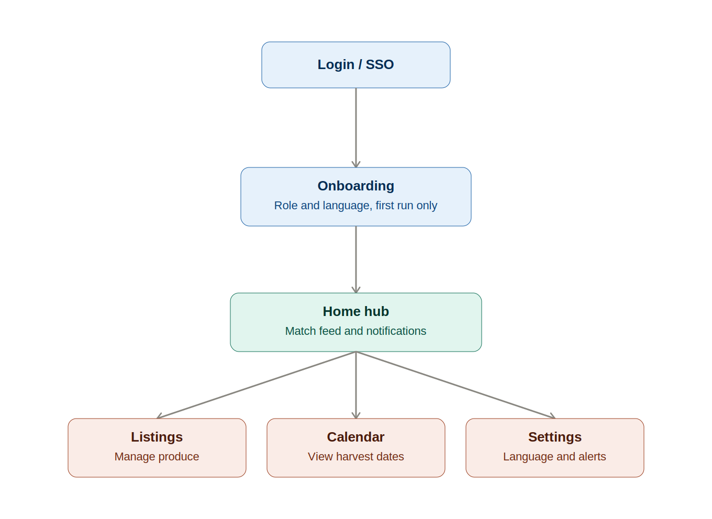
Figure 1 — Top level navigation flow
Detail flow for listings and demand requests: farmers move from My Listings to Create/Edit Listing, buyers move from Buyer Demand Board to Create Demand Request, and both paths converge at Match Detail and Rating.
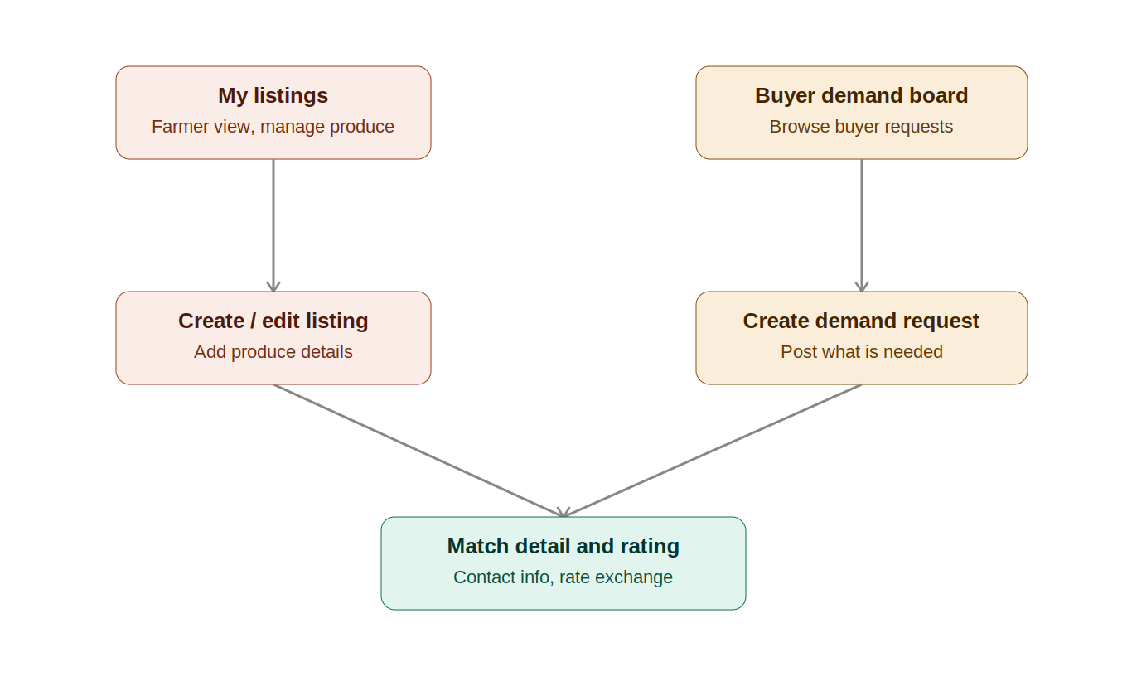
Figure 2 — Listings and demand request detail flow

5. REST API and Back-End Architecture

5.1. Structural plan
The custom REST API is the single source of truth for all shared data in FromTheFarm: farmer and buyer profiles, produce listings, demand requests, and the matches generated between them. It is responsible for all server-side validation, for running the matching algorithm across the full dataset (a calculation that cannot be performed reliably on a single device, since no device has visibility into other users' listings or demand), for gating contact information until a match is confirmed, and for reconciling records created offline once a device reconnects. The Android app itself never writes directly to the database, as every write passes through the API. Which is also responsible for triggering push notifications via Firebase Cloud Messaging whenever a new match is found.

5.2. Development stack and hosting
The API is built using ASP.NET Core Web API (C#), hosted on Azure App Service using Azure for Students. Data is stored in Azure Cosmos DB, a NoSQL document database, chosen over a relational store because the app's core entities (listings, demand requests, and the matches between them) read naturally as self-contained JSON documents rather than normalised relational rows, and because Cosmos DB directly satisfies the NoSQL requirement specified for the final stages of development, avoiding a later migration. Authentication is handled by Firebase Authentication using Google Sign-In; the API validates the Firebase-issued ID token on every request rather than managing credentials itself.

5.3. Endpoint specification
All endpoints are prefixed /api/v1 and exchange JSON. Every request (aside from the initial session exchange) requires a valid Firebase ID token in the Authorization header, from which the API derives the calling user's identity. No endpoint accepts another user's ID as a path parameter, to prevent one user querying another's private data.

Auth & Session

POST /auth/session
- Purpose: Exchanges a Firebase ID token for an app profile, creating one on first login or retrieving the existing one otherwise.
- Request body: firebaseIdToken (String, required), deviceLanguage (String, optional — used only if no profile exists yet).
- Response (200 OK): userId (Guid), isNewUser (Boolean), role (String or null), onboardingComplete (Boolean), profile object containing displayName (String), language (String), searchRadiusKm (Integer).

User Profile & Settings

GET /users/me
- Purpose: Returns the authenticated user's full profile and settings.
- Response (200 OK): userId (Guid), displayName (String), role (String: "Farmer" or "Buyer"), language (String, ISO 639-1), searchRadiusKm (Integer), notificationsEnabled (Boolean), biometricLockEnabled (Boolean), createdAt (DateTime).

PUT /users/me
- Purpose: Updates settings; also used to complete onboarding (role, language, radius).
- Request body: role (String), language (String), searchRadiusKm (Integer, 1–100), notificationsEnabled (Boolean), biometricLockEnabled (Boolean)
- Response (200 OK): updated profile object, same shape as GET /users/me.

Listings

GET /listings
- Purpose: Returns the authenticated farmer's own listings, or a nearby browsable set for buyers.
- Request Body: mine (Boolean), cropType (String, optional), maxDistanceKm (Integer, optional, defaults to the user's profile radius)
- Response (200 OK): array of listing objects, each containing listingId (Guid), cropType (String), quantity (Decimal), unit (String), harvestDate (Date), location (latitude and longitude as Double), photoUrl (String or null), status (String: "Active", "Matched", "Expired"), createdAt (DateTime)

POST /listings
- Purpose: Creates a new listing. Supports offline-first creation via an optional client-generated identifier used for reconciliation.
- Request body: clientGeneratedId (Guid, optional), cropType (String, required), quantity (Decimal, required, must be greater than 0), unit (String, required), harvestDate (Date, required), location (Double latitude/longitude, required), photoBase64 (String, optional)
- Response (201 Created): full listing object.

PUT /listings/{listingId}
- Purpose: Updates an existing listing. Same request body as POST, excluding clientGeneratedId.

DELETE /listings/{listingId}
- Purpose: Soft-deletes a listing, setting its status to a terminal state while preserving history for any matches already generated against it.

Demands

GET /demands
- Purpose: Returns the authenticated buyer's own demand requests, or a nearby browsable set for farmers.
- Request Body: mine (Boolean), cropType (String, optional), maxDistanceKm (Integer, optional)
- Response (200 OK): array of demand objects, each containing demandRequestId (Guid), cropType (String), quantityNeeded (Decimal), unit (String), deadline (Date), location (Double latitude/longitude), status (String: "Open", "Matched", "Expired"), createdAt (DateTime).

POST /demands
- Purpose: Creates a new demand request.
- Request body: clientGeneratedId (Guid, optional), cropType (String, required), quantityNeeded (Decimal, required), unit (String, required), deadline (Date, required), location (Double latitude/longitude, required).
- Response (201 Created): full demand object.

PUT /demands/{id} and DELETE /demands/{id}
Mirror the Listings update and soft-delete behaviour above.

Match Feed

GET /matches
- Purpose: Returns the ranked match feed for the authenticated user. A farmer sees demand matches for their listings, a buyer sees listing matches for their demand requests. The user is identified from the authentication token rather than a path parameter, a deliberate refinement over a userId-in-URL approach, since accepting another user's ID in the path would allow one user to view another's private match feed.
- Response (200 OK): array of match objects, each containing matchId (Guid), score (Decimal, 0.0–1.0), a counterpart object with cropType (String), quantity (Decimal), unit (String), distanceKm (Decimal), relevantDate (Date), and status (String: "Suggested", "Confirmed", "Completed").

GET /matches/{matchId}
- Purpose: Returns full detail for a single match, including counterpart contact information only once confirmed.
- Response (200 OK): matchId (Guid), score (Decimal), status (String), counterpartContact object with displayName and phone (both String or null, populated only when status is "Confirmed"), plus embedded listing and demand snapshots

POST /matches/{matchId}/confirm
- Purpose: Transitions a match from "Suggested" to "Confirmed," unlocking the counterpart's contact information.

Ratings

POST /matches/{matchId}/rating
- Purpose: Records a one-time trust rating after a completed exchange.
- Request body: thumbsUp (Boolean)
- Response (201 Created) Validation: only accepted once per match, and only once the match's status is "Completed."

Calendar

GET /calendar
Purpose: Returns listings grouped by harvest date, derived from existing listing data rather than a separate write model, to power the harvest calendar screen.
Request Body: month (Integer), year (Integer)
Response (200 OK): array of objects containing date (Date), listingCount (Integer), listingIds (array of Guid).

5.4 Matching algorithm summary
The scoring logic behind GET /matches is detailed in Section 3 above: a weighted combination of distance (35%), crop type match (30%), quantity fit (20%), and freshness window (15%), with a 0.4 minimum score threshold for inclusion in the feed.

6. UML System Architecture Diagrams

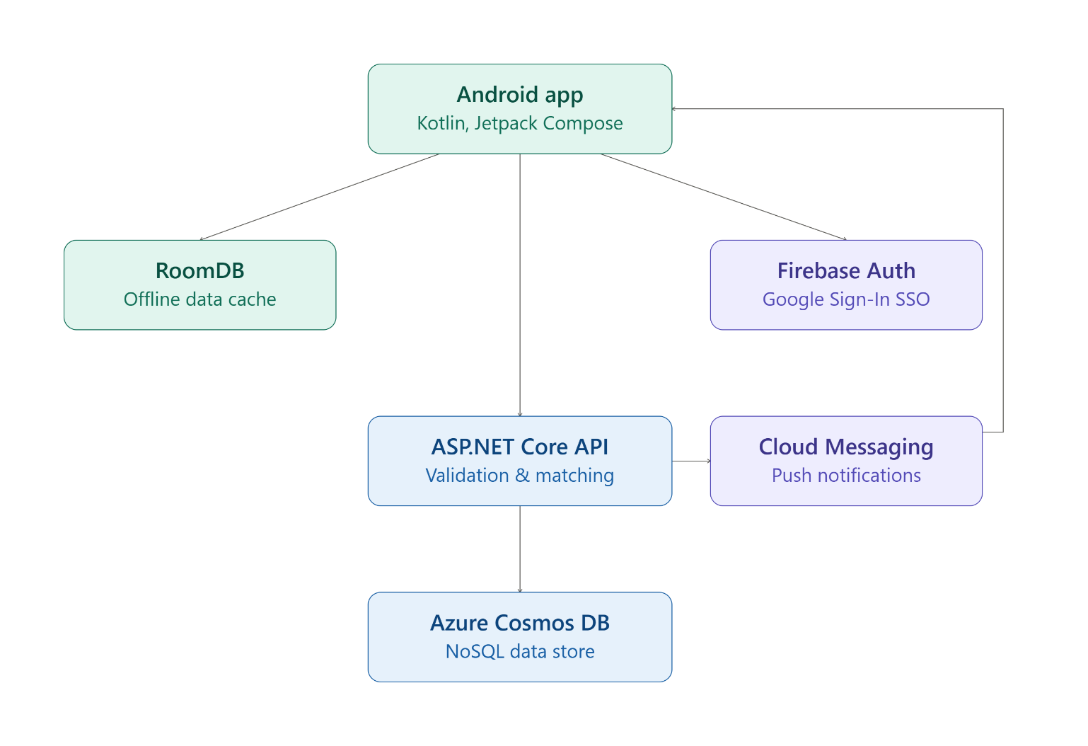
Figure 3 — FromTheFarm System Architecture
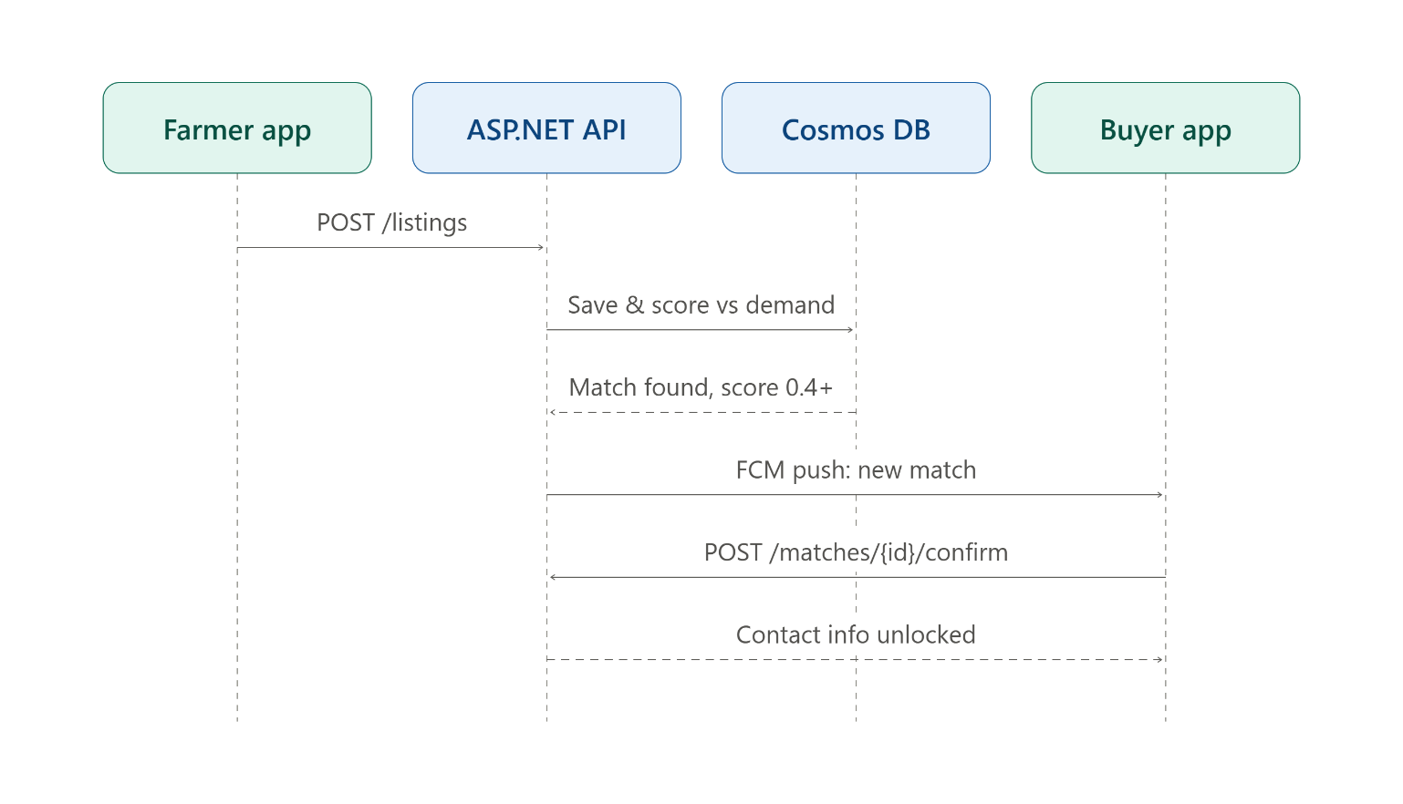
Figure 3 — FromTheFarm Sequence Diagram

7. Data Models and Schema Definitions
TO COMPLETE — Greg
List every piece of data the app needs to capture and persist — user profile, listing, demand request, match — with explicit data types (String, Int, Boolean, Date, etc.) for every field.
Keep this in sync with Kaehil's endpoint schemas once finalised — these should describe the same fields.

8. Project Management Plan (Gantt Chart)
TO COMPLETE — Kaehil (or whoever owns final assembly)
Insert a visual Gantt chart with granular, specific engineering tasks (not vague phases) covering Part 1 through the final POE.
Explicitly allocate dedicated time for testing and bug-fixing cycles, as the brief requires.
The group's task-assignment breakdown from earlier can be adapted into this Gantt chart rather than rebuilt from scratch.

9. Conclusion
TO COMPLETE — Whole group (short, write together)
Summarise the design choices made across all sections.
Confirm the group's structural readiness to move into Part 2 (build phase).

10. References
TO COMPLETE — Whole group — add as you go
List every external design framework, architectural pattern, and piece of engineering documentation used, in the module's required referencing style.
Add references incrementally as each section is written rather than all at the end — it's much easier to trace where each source was used.

